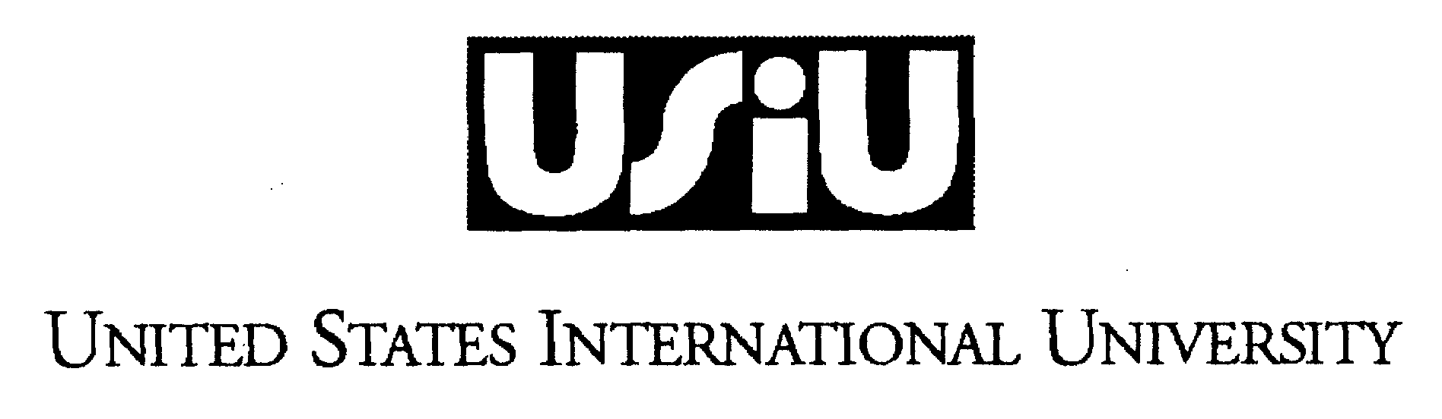
MEMORANDUM

FROM: Prof. Mathew Buyu - DVCAA
DATE: 20th NOVEMBER, 2012
CC: DEANS
TO: FACULTY
RE: EXAMINATION REGULATIONS

- INVIGILATION
- The supervisor should take the following steps prior to the commencement of he examination:
- Ensure that there are no materials on the board, walls, floor or furniture that might facilitate cheats.
- Ensure that the seating plan does allow sufficient distance between candidates.
- Candidates will be allowed into the examination room no earlier than 5 minutes before the commencement of the examination.
- Only candidates with valid USIU student identity cards will be admitted into the examination room. A candidate is required to wear his or her identity tag throughout the duration of the examination. The invigilator should check the cards to ensure that they are authentic and that nothing is scribbled on them.
4. As candidates enter the examination room they must surrender the following before them take up their seats:
- Bags
- Overcoats
- Caps/hats
- Books
- Notes
- Papers
- Cellphones
- Calculators
- Scientific watches
- Portable audios and
- any other objects that might be used for cheating
- Calculators, log tables and geometrical sets shall not be allowed unless otherwise directed by the instructor.
- The invigilator reserves the right to confiscate any unauthorized materials.
- No candidate will be allowed into the examination room 20 minutes after the commencement of the examination.
- No candidate will be permitted to leave the examination room while the examination is in progress except in cases of emergency. Such emergencies will not include bathroom visits.
- Invigilators must ensure that absolute silence is observed in the examination room.
- At least 5 minutes prior to the commencement of the examination invigilators will:
- Take a roll call using the official class list.
- Send away any student whose name is not on the official class list.
- Ask the candidates to surrender any unathorized material.
- Draw the attention of the candidates to the consequences of cheating in an exam
- Draw the attention of the candidates to the instructions on the front cover of the answer books and in the question papers.
- Once the question paper is issued an invigilator must be alert and in attendance until the scripts are collected.
Below are some of the cheating methods in order of popularity:-
- Swapping and substitution of answer sheets or booklets
- Swapping question papers
- 'microchips' or condensed/minimized notes smuggled using devices such as
- ball pens
- pencil pouches
- shoes
- ties
- shirt/blouse sleeves
- limbs, especially palms, arms and thighs
- chairs
- calculators (especially sliding)
- cell phones
- spectacle cases
- walls and roof
- walkman

- Stealing a glance at other candidate’s answers.
- Feigned bathroom 'emergencies'
- Candidate substitution
- Whispers and gestures.
- There must be at least one invigilator for every 40 students in an examination room.
- To thwart cheats, the invigilators should:
- Monitor the candidates continuously.
- Never bring reading material or own work to the examination room.
- Never return assignments, quizzes or term papers during the exam.
- Walk around the room from time to time, inspecting pencil sets and other items that could be used to hide 'microchips'. Invigilation from the back is particularly effective in a room with many candidates and having 2 or more invigilators.
- If an invigilator directly observes or otherwise determines (based on other evidence) that an act of cheating or misconduct has been committed or attempted s/he should take the following steps:
- Caution the candidate(s) involved that they are suspected of cheating.
- Confiscate or take note of the suspected material but allow the candidate to continue with the examination.
- Make a description of the suspected misconduct with specific date, time and circumstances and witnesses.
- Send the report to the Dean with a recommendation as to whether the suspected misconduct is a serious violation or an infraction under USIU academic code of conduct.
- MISSING EXAMINATIONS
In the past some students have failed to present themselves for scheduled examinations without good cause.

All students must ensure that they familiarise themselves with the examination timetable so as to report for each examination at the appointed time and place.
THERE ARE NO MAKEUPS FOR MISSED OR FAILED EXAMS.
However, in the event of serious illness, bereavement or accident the victim should report the matter to the appropriate Dean and instructor as promptly as possible. Only those cases reported immediately and supported with evidence will be considered.

